……….
30723 Sodaville Rd Lebanon, Oregon
November 2015 Volume 15, Issue 11

City Hall (541) 258-8882 Mayor Suzie Hibbert email: sodaville@cityofsodaville.org
Web Address: www.sodaville.org Judy Smith – City Administrator
000000000000…………………………………………………………………………………………..000000000000000000000000000000

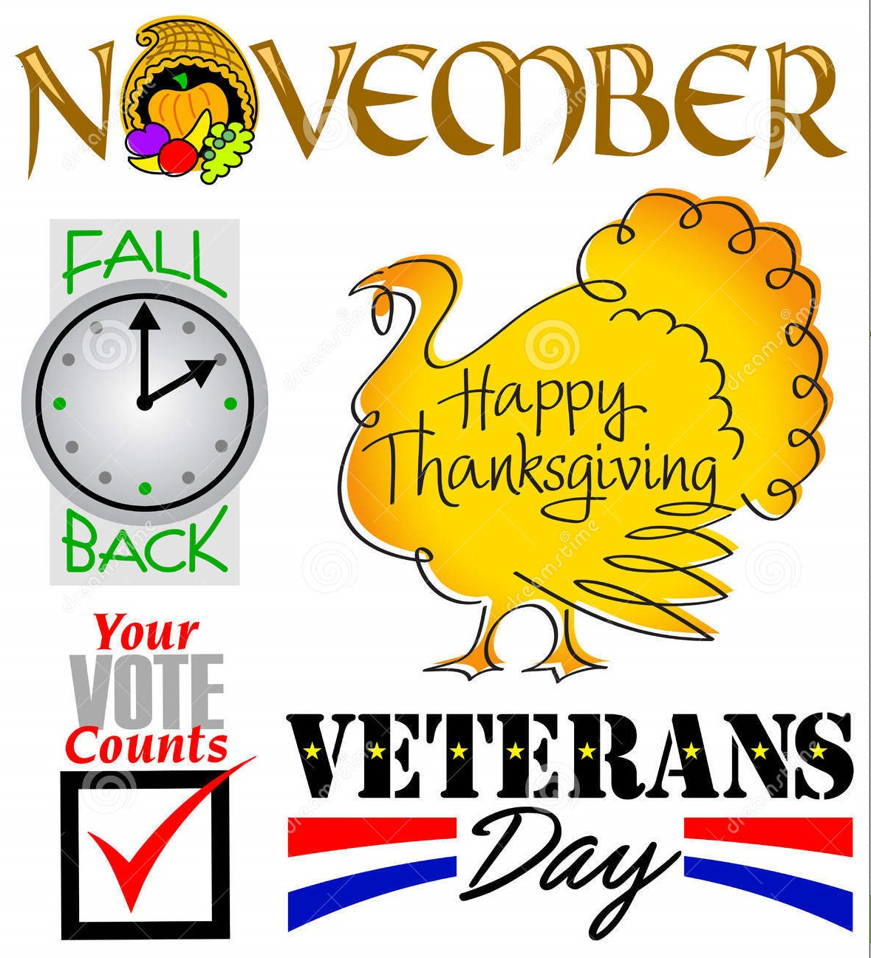
City Council Meeting City Hall Hours
7:00 pm November 19, 2015 Mon.–Thurs. 10 am–2 pm

City Update
City Hall will be closed on Wednesday November 11 for Veterans Day
and Thursday November 26 for Thanksgiving Day.
As many of you have noticed, New Day Trucking has been hauling in water from Lebanon. The City has purchased almost 150,000 gallons so far, with no end in sight. This is an expensive undertaking. Each time the truck works a day, it costs $600-$750 not including the water purchased. I am currently working on an ECWAG grant (Emergency Community Water Assistance Grant) through USDA. I am hoping that the costs incurred from this water emergency will be reimbursed through the grant. Along with that reimbursement, I am requesting around $125,000 to help rehabilitate the existing wells. This grant has never been applied for in Oregon, so please keep your fingers crossed that it will be approved. I will update you as I find out more.

A few months ago I was invited to attend the Ford Foundation Leadership Program. The “Cohort” while training, has to choose a project or an event to work on. I have submitted the new park at the corner of Sodaville Road and Main Street as a possible project. The project can cost between $2,000 and $12,000 and the monies will come from the Foundation as a matching grant any fund raising the Cohort does. Out of 17 projects or events submitted, the park is in the top 5. I will be doing a presentation of the project at the November 20 meeting. Included in my presentation will be citizen ideas. If you have a want or idea for the park please let me know. One of the members of the Cohort is an employee of Hamilton Construction. The company is currently working on the Siuslaw Bridge and has offered to donate some beautiful concrete barriers they are removing from the bridge. If the city accepts them, they will transport them to the new park. The barriers can be used along the front to keep children from running out onto Sodaville Road and they can also be used as a type of retaining wall along the back. Each weighs 7,000 pounds. The Citizen Planning Committee is working hard on this project so if you are interested in participating, please contact City Hall.

Judy Smith, City Administrator
Mayor’s Message
November is here and still not enough rain. ​The leaves are still crunchy as I write this.
Thanksgiving is coming up and let’s hope we can be thankful for steady downpour of rain. We
will be hauling in water for sometime now until we get enough to reach our wells, some of them are over 300 feet deep. Hauling water is very expensive and the bill is mounting. Continue to
conserve all you can.

We do have several good things to tell you.​ My favorite is that we haven’t heard of any
gunshots in town this month. Maybe someone got the message? Sure hope so!

The Naming of the Park Contest ends November 12th at 12:00pm the winner receives a
$50 gift card. ​Some history behind your entry may help you win the Contest. We are looking
for something meaningful and catchy. But be sure to enter all of your ideas, you never know
what might click as perfection! Entries can dropped off at the City Office, the water payment
box or emailed to either city hall or myself. ​sodaville@cityofsodaville.org​ ​Hurry, time is
almost up!

A Contest we have going for the school age children grades 4­12 is “If I were Mayor for day…” ​This is open to all Sodaville resident students, homeschool and Sand Ridge Charter
School has been invited to join us this year, as we haven’t had any interest in the past. Please
check the ​Sodaville.org ​website for all details. Prizes are included.

Citizen Committee’s Work Party update.​ I suggest a big thank you for trying to make your City a better place. Thank you to Gail Bartholomew, Christine Bailey, Brian and Cheryl Lewis, Sherry Fuller, Logan Hibbert, Stan Smith and I showed up to finish the project we started in May. We
had a Chili Cook­off lunch and headed home to enjoy the rest of the day. We continue to ask
for your ​ideas​ of what you want,​ Playground equipment? Basketball court? or just a hoop?
Horseshoe pit?

We have on our website the ​Willamette Neighborhood Housing Opportunity details ​that
offer help in purchasing a home, or retaining your current one.

Enjoy the blessings of friends and family during the upcoming holidays!

Suzie Hibbert, Mayor mayorhibbert@yahoo.com

Public Works Newsletter
The Fall cleanup at the City’s new park was a huge success. Not a lot of people showed up for the cleanup but those that did gave it their all and everything the committee wanted to do got done. Thank you to all of the citizens committee for making this event happen. A special thank you to Councilor Brian Lewis for the use of his tractor, which made quick work of the vegetation. Following the cleanup several piles of debris were burned. Several more piles remain but should be burned this season making way for more improvements in the park. If anyone would like to become involved in developing the City’s new park please call City Hall at 541-258-8882 for more information.

With November upon us the City is entering its third month of water restriction. Currently the City’s well are not improving but don’t seem to be declining further. Please continue to conserve water wherever possible until the City notifies you that the current restriction is over. Until such time the City will continue to purchase water from the City of Lebanon to supplement the water supply.

Stan Smith, Public Works Director
Country Girl Quilting
*Long-arm Machine Quilting
Call Sharon Hill and Joleana Altom at 541-258-2256

Carries Country Inn Adult Foster Home
is located at 30785 Washington Street in Sodaville. “A safe, comfortable home where you can keep your dignity, respect and independence.” For information call: 541-570-1430

If you have any announcements, information or ads you wish to have published in the newsletter, please call before the 6th of the month and I will be happy to insert them! “The City of Sodaville is an equal opportunity provider and employer.”

